EnVision Math Login Instructions for Students:
New this school year, students will use their district Google account credentials to log into Pearson EnVision Math. You will no longer use a username or password to access your Math resources and class assignments.
Please find our login instructions below:

- Log into your district Google account (or Gmail)
  - Your email is studentID@jacksonsd.org
  - If this is your first time logging into Gmail, your password is welcome#jsd.
- Open a new tab and go to your school website (e.g. holman.jacksonsd.org)
- At the top of the page, go to “FOR PARENTS & STUDENTS”
- Click on “Envision Math Login”
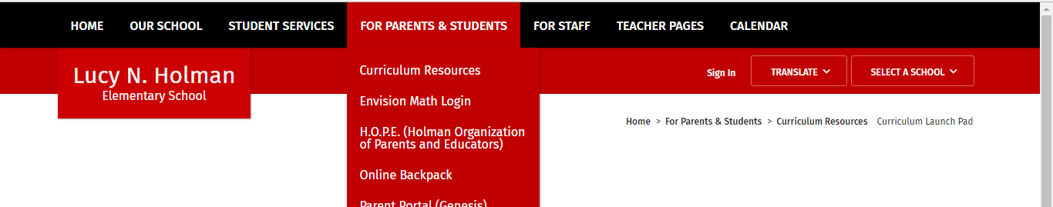
- You will be taken to the Pearson envision website and will be automatically signed in.
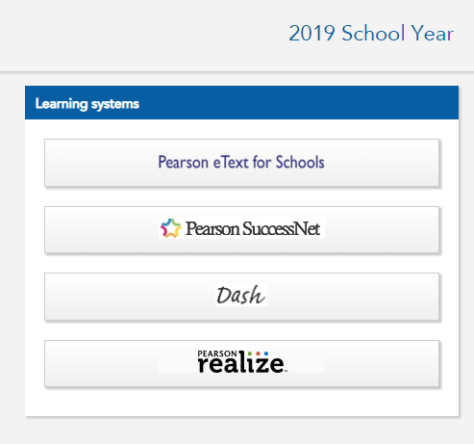

- Click Pearson Realize on the right side and you’re ready to get your math on!

